**Lab07 Instructions – NAT (4 Marks)**

**What you need:**

1. Latest Packet Tracer on your laptop
2. Lab 06 PT submission you have provided

**Goal:**

You will be creating a static NAT to protect Server from public access using Lab06 Submission.

**What you need to submit:**

1. This documentation with answers.
2. Your new Lab 07 PT file.

**Highlights of Tasks:**

1. Copy Lab 6 Packet Tracer File that you have submitted into a new Lab 07 submission file. (e.g. New file: Lab07Submission)
2. Open your newly copied Lab 07 PT file.
3. From the PC, open the web browser and enter the IP address of the server.
4. Enable the Server Side router’s NAT with correct IP Address RE-wiring (see hints)
5. From the PC, open the web browser again and enter the public IP address of the serving router.

**Answer the Following Questions with Screen Shots:**

Q1: What is the PC’s IP address on your Lab 07 PT file?

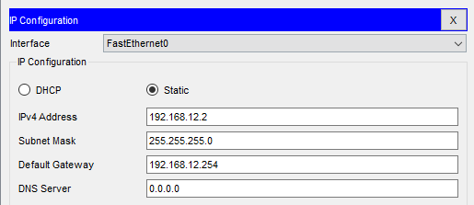

Q2: What is the Servers’s IP address on your Lab 07 PT file?

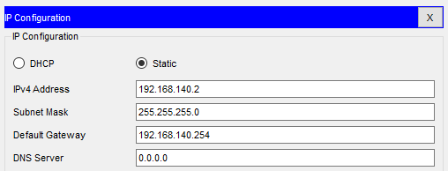

Q3: What are the Server Side router’s connected NIC’s IP addresses on your Lab 07 PT file?

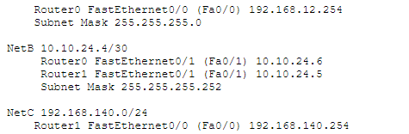

Q4: What IP address did you use to access the web server in the URL before NAT is enabled?

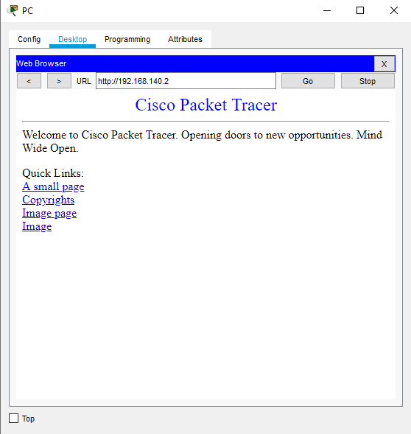

Q5: What IP address did you use to access the web server in the URL after NAT is enabled?

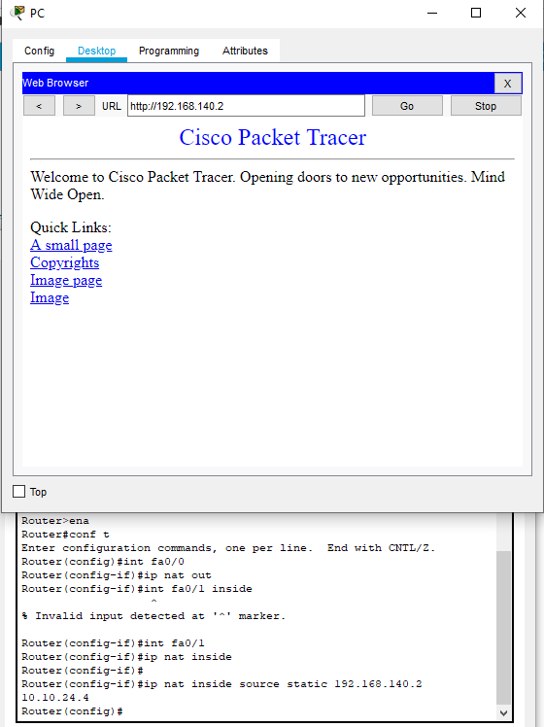

**Hints:**

Hint1: Please watch the following recommended video to complete this assignment.

<https://www.youtube.com/watch?v=dUfKR2wC1Y4>

Hint 2: Router CLI commands Interface: Make sure CLI interface is not hidden from Packet Tracer Preferences…

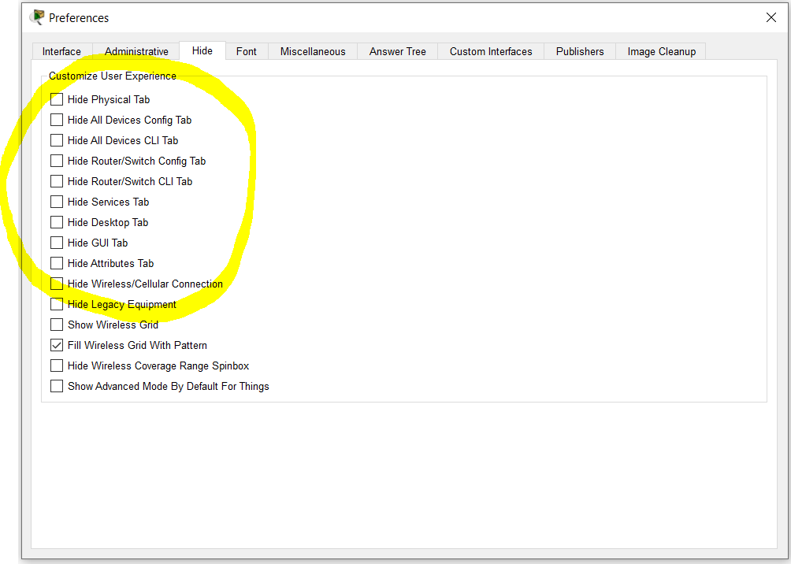

Hint3:Sample commands for static NATing. Use your IP addresses accodinngly.

